# Wikiversity

## 🎓 Definition

**# Source**: **Windows ScreenShots (using Lightshot Program)** **From Site -> https://www.wikimedia.org/ at [10/27/2025]**

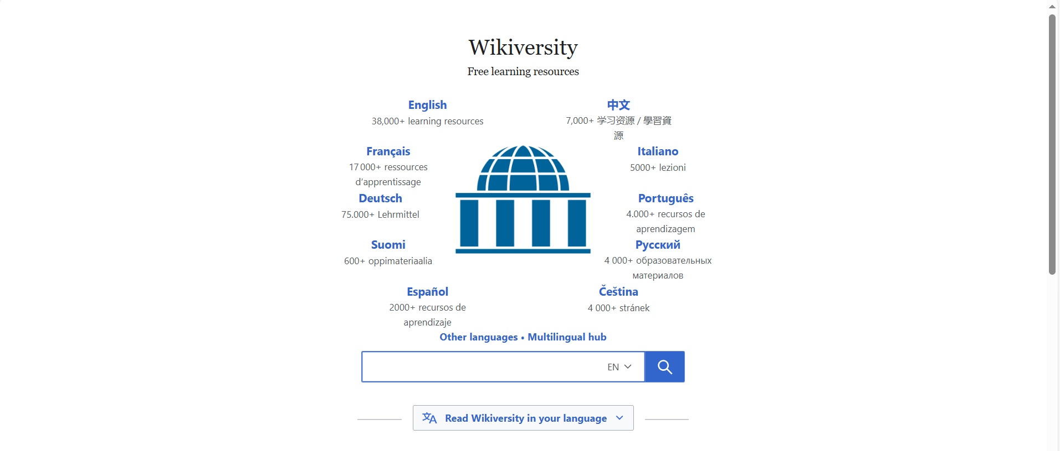

**# Source**: **Chatgpt (GPT-5-Standard) at [10/27/2025]**

**Wikiversity** is one of the **Wikimedia Foundation’s free education projects** — just like Wikipedia, but focused on **learning and teaching materials** instead of encyclopedic articles.

**Wikiversity** is a **free online learning platform** where anyone can:

* Create and share **educational materials** (lessons, tutorials, study guides, etc.)
* Organize **learning projects** and **courses**
* Collaborate on **research and study topics**

It’s like an open, community-built **virtual university**, but **without grades or formal enrollment**.

## 🌍 Main Purpose

**# Source**: **Chatgpt (GPT-5-Standard) at [10/27/2025]**

To support **learning at all levels** — from school to university to lifelong learning — through **open educational resources (OER)**.

## 🧠 What You Can Find There

**# Source**: **Chatgpt (GPT-5-Standard) at [10/27/2025]**

* Courses and lessons in many subjects (science, language, history, art, technology, etc.)
* Collaborative projects and discussions
* Research projects shared openly
* Learning communities built around shared interests

## 🕊️ Key Idea

**# Source**: **Chatgpt (GPT-5-Standard) at [10/27/2025]**

Anyone can **learn**, **teach**, or **research** — for free, together, from anywhere in the world.  
It follows the **same “wiki” model** as Wikipedia, meaning **anyone can edit and improve** the content.

## Wikipedia vs Wikiversity

**# Source**: **Chatgpt (GPT-5-Standard) at [10/27/2025]**

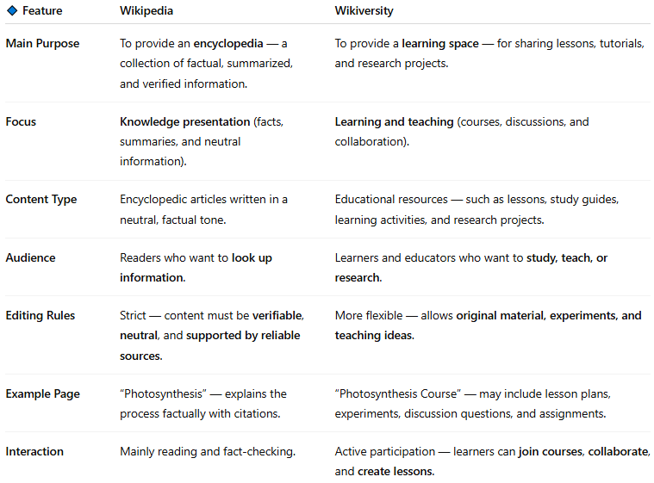

| **🔹 Feature** | **Wikipedia** | **Wikiversity** |
| --- | --- | --- |
| **Main Purpose** | To provide an **encyclopedia** — a collection of factual, summarized, and verified information. | To provide a **learning space** — for sharing lessons, tutorials, and research projects. |
| **Focus** | **Knowledge presentation** (facts, summaries, and neutral information). | **Learning and teaching** (courses, discussions, and collaboration). |
| **Content Type** | Encyclopedic articles written in a neutral, factual tone. | Educational resources — such as lessons, study guides, learning activities, and research projects. |
| **Audience** | Readers who want to **look up information**. | Learners and educators who want to **study, teach, or research**. |
| **Editing Rules** | Strict — content must be **verifiable**, **neutral**, and **supported by reliable sources**. | More flexible — allows **original material, experiments, and teaching ideas**. |
| **Example Page** | “Photosynthesis” — explains the process factually with citations. | “Photosynthesis Course” — may include lesson plans, experiments, discussion questions, and assignments. |
| **Interaction** | Mainly reading and fact-checking. | Active participation — learners can **join courses**, **collaborate**, and **create lessons**. |

**🧩 In Simple Words:**

* **Wikipedia** = Learn **about** something.
* **Wikiversity** = Learn **how** something works (by studying, teaching, or researching together).

## ✅ In short:

**# Source**: **Chatgpt (GPT-5-Standard) at [10/27/2025]**

**Wikiversity = a free, open, collaborative learning platform** — part of the Wikimedia family — where people create and share educational resources.